Assignment 1:

1) Write a query to get a Product list (id, name, unit price) where current products cost

less than $20.

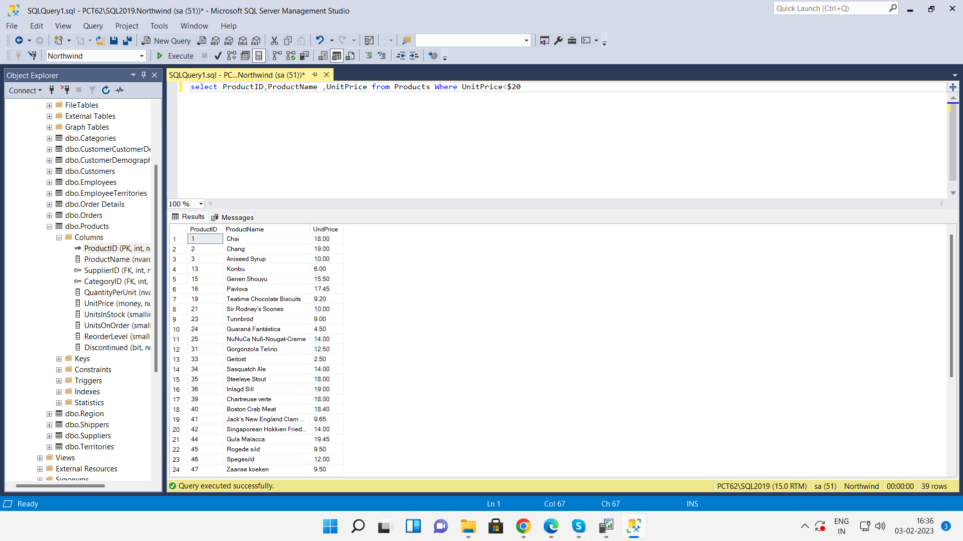

2) Write a query to get Product list (id, name, unit price) where products cost between

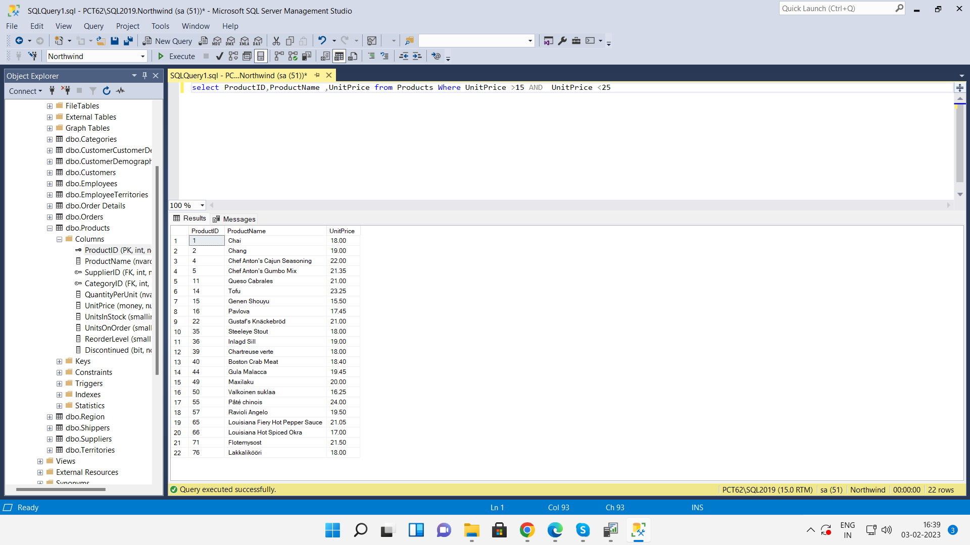 $15 and $25.

3) Write a query to get Product list (name, unit price) of above average price.

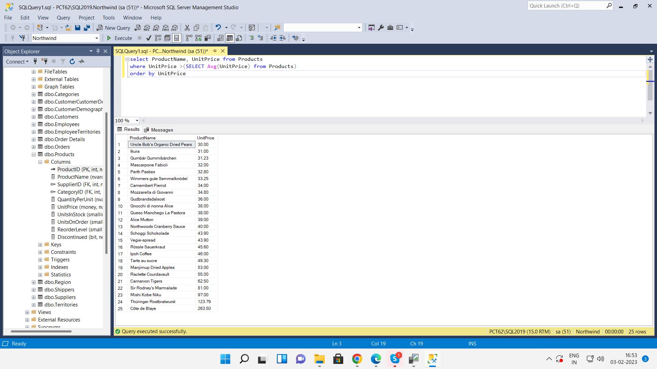

4) Write a query to get Product list (name, unit price) of ten most expensive products.

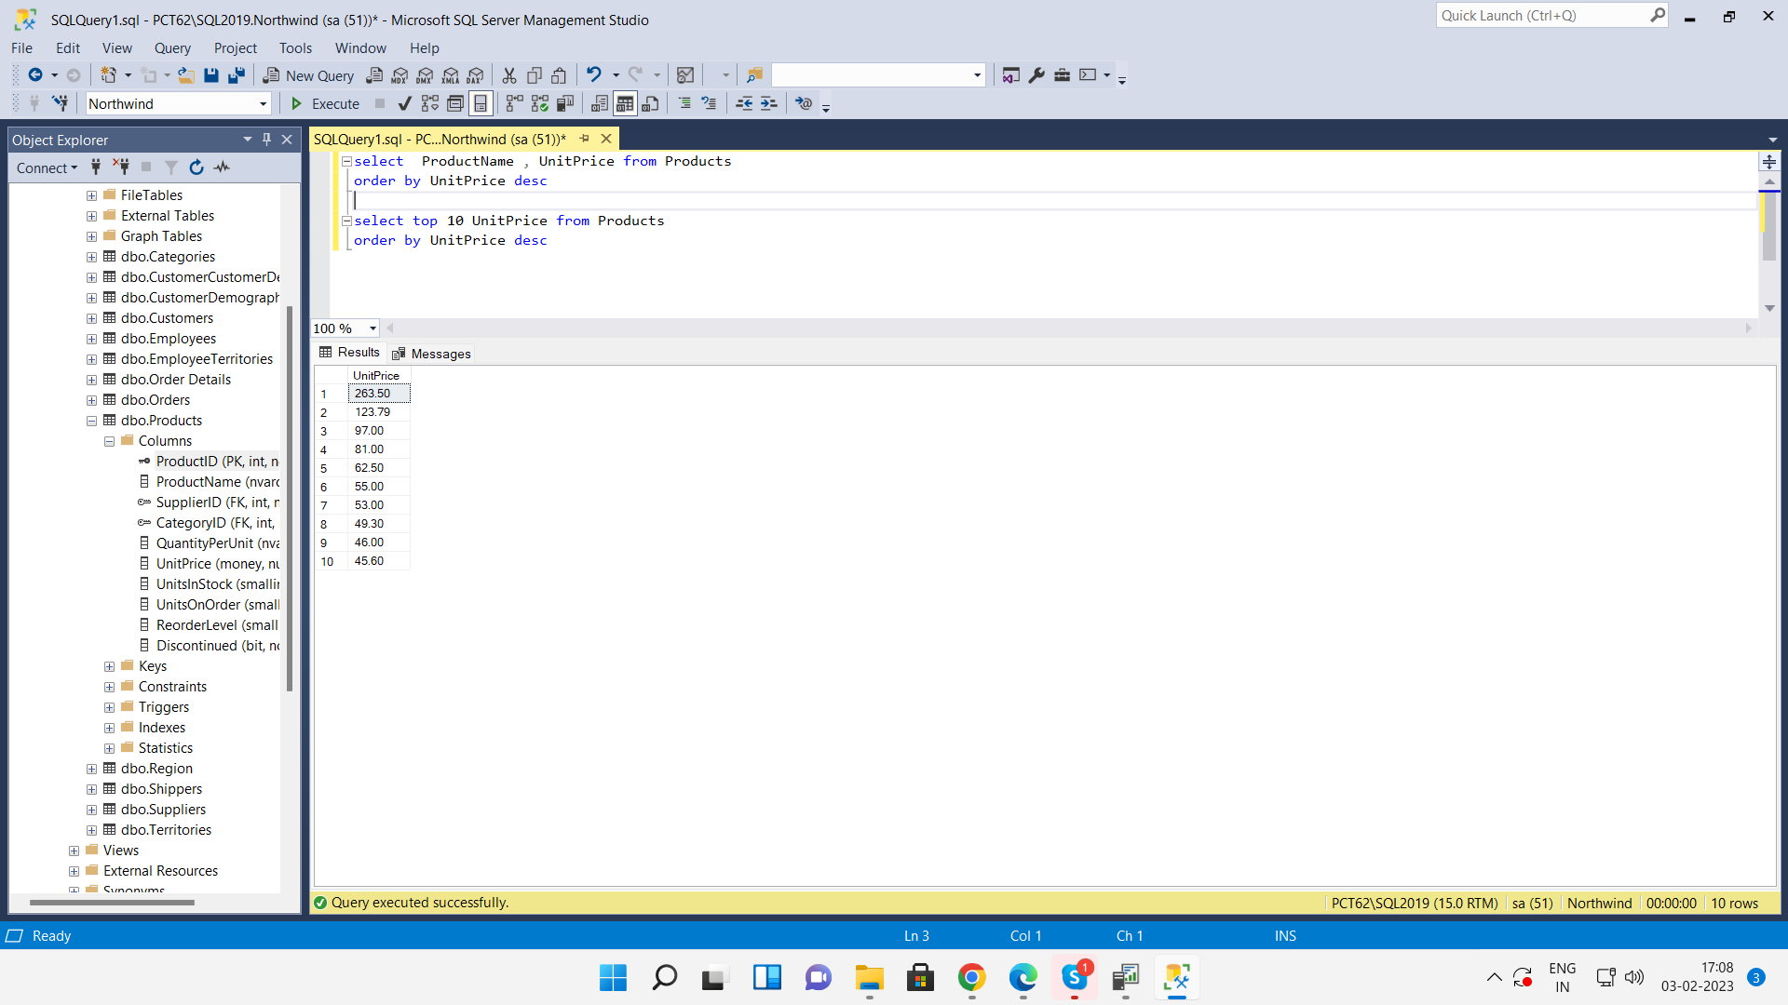

5) Write a query to count current and discontinued products.

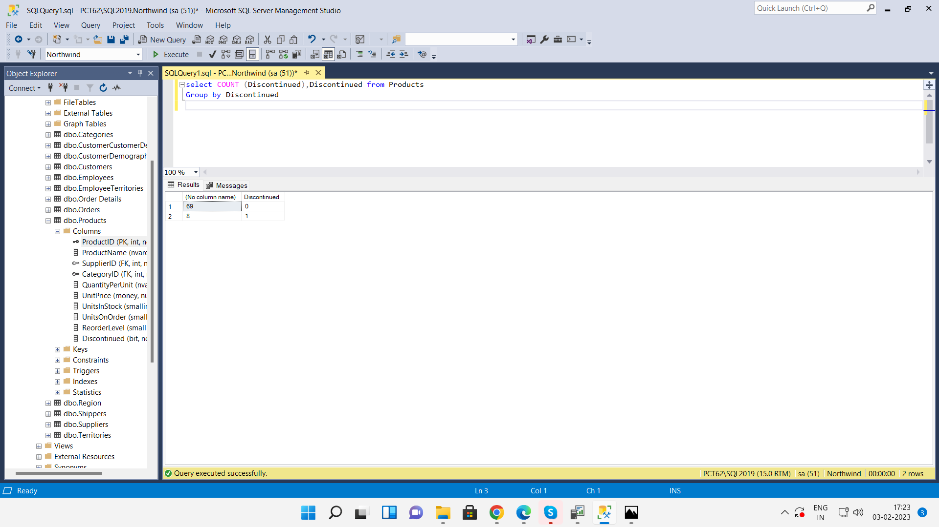

6) Write a query to get Product list (name, units on order , units in stock) of stock is less

than the quantity on order.

